Menu Planning Considerations for Early Years Settings
Early Start Nutrition
Setting the Scene

A healthy balanced diet and regular physical activity are essential to children’s health and wellbeing. The early years are a key time to encourage children to learn about food, eat well and set the foundations for their future health and wellbeing.

As a childcare setting you have a great opportunity to provide healthy and tasty meals for young children while they are in your care. Children in full day care will receive up to 90% of their daily energy requirements from you, therefore it’s important that the food and drink you provide is balanced across the day.

Current evidence suggests there is a wide variation in the quality of food offered in childcare settings in the UK. Some nursery meals were found to be low in iron and zinc, portion sizes were both too large and too small and not all settings offered an afternoon snack.

What do the guidelines say?
There are a number of guidelines to support early years settings to provide children with the variety of foods they need while establishing positive eating habits:
- Action for Children’s, Eat Better Start Better guidelines support settings to meet the nutritional requirements of young children across the whole day
- Early Years Foundation Stage (EYFS) guidelines state “meals, snacks and drinks must be healthy, balanced and nutritious”
- Ofsted’s Common Inspection Framework will look at the extent to which early years settings are successfully supporting pupils to gain “knowledge of how to keep themselves healthy” and “make informed choices about healthy eating, [and] fitness”
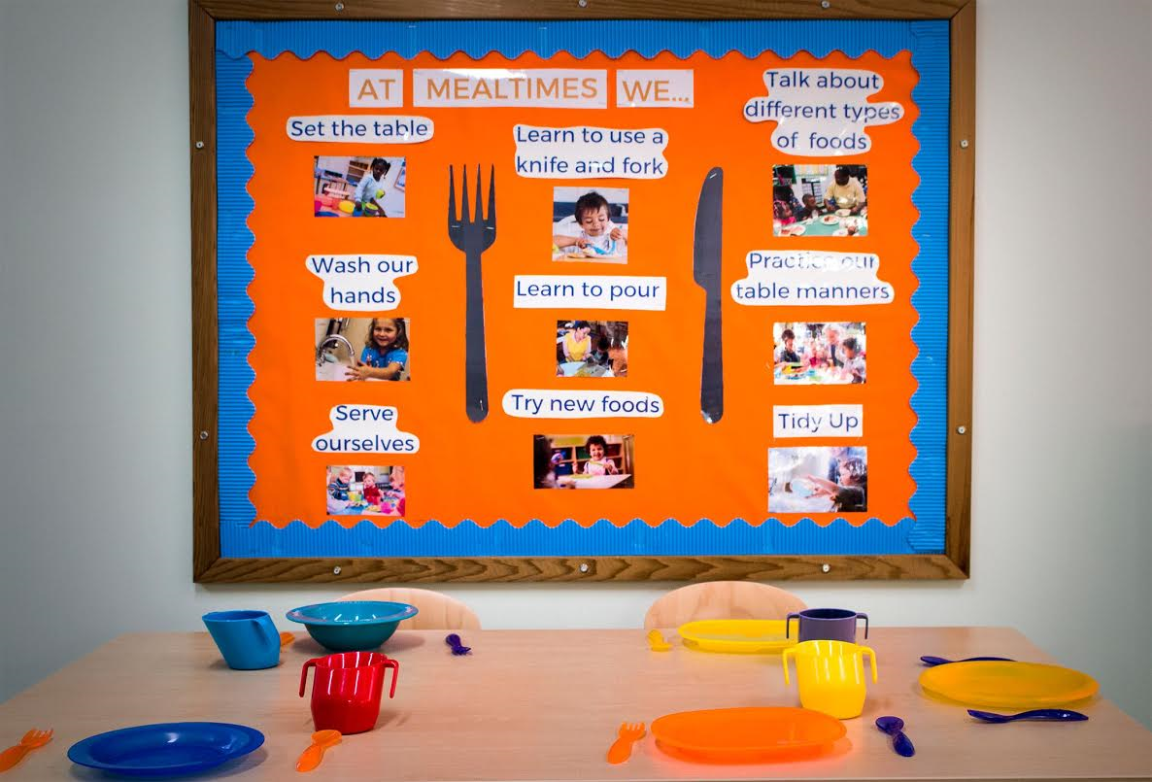
What can you do as an early years setting in Cornwall to ensure your menus are balanced and in- line with national guidelines?

Top Tips from the Early Start Nutritionists:
- Plan your menu to include 3 main meals breakfast, lunch, tea and 2 snacks each day. A dessert should be offered with lunch and tea
- Plan your menu over a number of weeks and introduce a new menu cycle at least twice a year
- Consider suitable alternatives for any children with diagnosed allergies or dietary restrictions and consider any cultural dietary requirements
- The menu should include timing of meals and snacks and ensure appropriate timings between meals (ideally 1.5 to 3 hours)
- Keep menus on display in your setting/website to allow parents to offer appropriate meals or snacks at home and ensure a balanced diet is maintained
- Water should be freely available throughout the day and children should be encouraged to help themselves. Drinks should be offered in open top or free flow cups.

Other Considerations:

To ensure meals are appealing to children plan menus to include a variety of foods, tastes, textures and colours

Colour
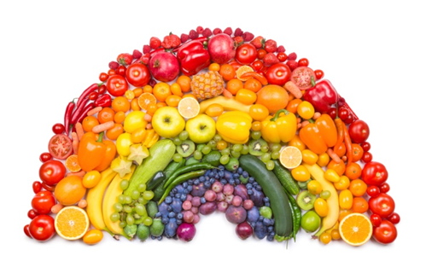
- It is important to choose a variety of colours to keep children interested and to make food look appealing

Variety
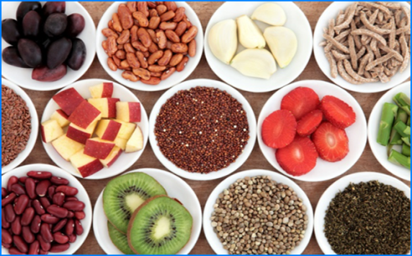
- A variety of foods should be served throughout the menu cycle
- This is essential to ensure a balance of nutrients as well as keeping children interested and excited by food

Taste
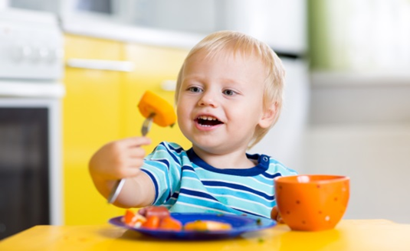
- Your menu should offer a variety of tastes
- Strive for an assortment of flavours across the day/week but keep individual meals relatively simple

Texture
- A combination of different textures increases appeal.
- Ensure your menu offers a variety of different textures for children to experience
- Offer foods that are crisp (lettuce), crunchy (crackers), chewy (dried fruit)*, soft (banana) and smooth (yoghurt).

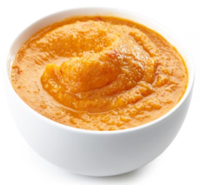

There are many benefits to planning a menu as it helps with food shopping, preparation and stock control within your setting. By planning a menu over a number of weeks, settings can ensure that they are offering a wide variety across each meal but also on different days of the week. Settings have reported cost benefits by buying items in bulk and sourcing foods which are in season. Menu planning provides a fantastic opportunity to tailor your menus to cultural events or you can link to areas of the EYFS for example, literacy, as many stories involve food. Your setting can show it’s commitment to being environmentally friendly as planning menus has been shown to reduce food waste.

Early years settings in Cornwall now have access to the Early Start Nutrition, Menu Planning training at a discounted rate, £25 incl. VAT! This training will support you:
- to develop the skills in planning breakfast, snacks, lunch/tea and dessert in line with the Eat Better Start Better voluntary food and drink guidelines
- to plan your menu to meet children’s cultural and dietary requirements
- support you to achieve the healthy eating section of the Healthy Under 5’s application.

This training is key for chefs and those responsible for updating menus and can be accessed 24/7 in your own time. You will receive a certificate of completion along with a range of supporting resources to support the implementation of the guidelines.

To book the training:
- Create your own personal online account https://www.earlystartgroup.com/nutrition/wellbeing-and-nutrition-my-learning-account-creation/
- Log into your account and book on the Menu Planning training https://www.earlystartgroup.com/courses/menu-planning/
- Use your Coupon Code to receive your discount: Cornwall2020

You can continue to keep up to date with early years nutrition guidelines by following the Early Start Nutrition team across our social media accounts.

@EarlyStartRNutr

@earlystartnutrition

https://www.facebook.com/EarlyStartNutrition

https://www.youtube.com/channel/UClxzD5EOI-gQ5aZDlrOshBA/videos?disable_polymer=1

