**Hospital Passport for people with Learning Disabilities**

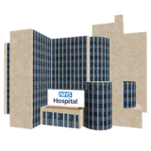

Please take this Hospital Passport if you have to go into hospital.  
  
This Hospital Passport gives staff looking after you important information about you. Please ask staff to read it.  
  
You can contact the Learning Disability Liaison Team when you are coming into the Hospital.

Telephone: Email:

Hospital Passport updated on: (month) ……… (year) 20......

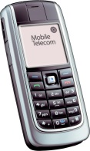

01872 254551

**rch-tr.LearningDisabilities@nhs.net**

*This Hospital Passport was developed by the Learning Disability Liaison Team within Plymouth Hospitals NHS Trust. This is based on the original work created by the Gloucester Partnership NHS Trust and Royal Cornwall Hospitals NHS Trust.*

RED

Things you **MUST** know about me

Name: NHS No:   
Likes to be known as:

Address: Tel No:

Date of birth: GP:

Please check my capacity to understand what is happening to me on each decision.



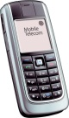





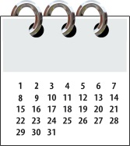

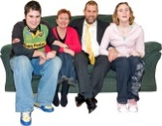

Next of Kin: Tel No:   
Relationship:

Care Provider: Tel No:   
Key worker/Main carer: Tel No:   
Known to social services? Yes / No  
Contact name: Tel No:

Who I would like you to contact first:   
Tel No:

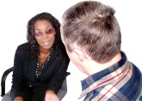

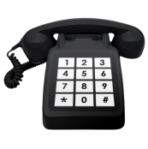

Religion/Religious requests:

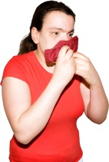

Allergies:

Current medical conditions:

Current medication (please bring mars sheet / px sheet):

End of Life plan in place: YES / NO

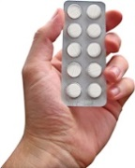

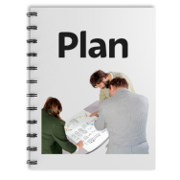

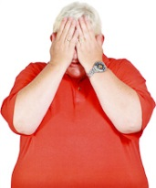

How I may react if I am anxious or find the situation challenging:

My preferred communication method to help me understand is:   
Speaking / Signing / Pictures / Other: \_\_\_\_\_\_\_\_\_\_\_\_\_\_\_\_\_\_\_\_\_\_\_\_

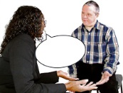

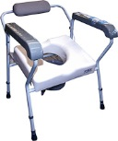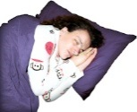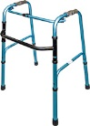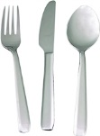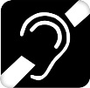E:\lores_images\Glasses.jpg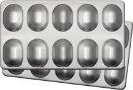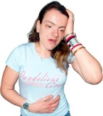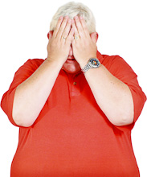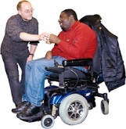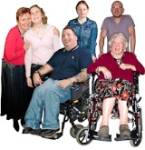

Amber

Things you **NEED** know about me

**For my safety** – e.g. bed rails, people to support me, what I understand?

**Level of support** – e.g. who needs to stay with me and how often?

**If I am anxious it helps if you…**

**Pain** – e.g. how you know I am in pain and what helps.

**Seeing/Hearing** – e.g. glasses, hearing aids?

**How I take medication** – e.g.oral / syrup / peg.

**Eating (swallowing)** – e.g. dentures, food cut up, choking, eating aids, help with feeding, peg.

**Drinking (swallowing)** – e.g. Small amounts, choking, what I like to drink, what I drink from.

**How I get around** – e.g. mobile, aids, hoist transfer.

**Going to the toilet** – e.g. independent, pads, catheter, aids needed.

**Personal care** – e.g. dressing, washing, etc.

**Sleeping** – e.g. sleep pattern, sleep routine, sleep system, posture?

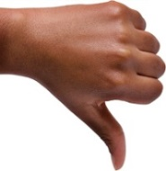

Produced by South West A2A

Date Created: January 2017 Reviewed: June 2017 Review Date: June 2019

Things I DO NOT like

Things I like

Think about – what upsets you, what makes you happy, things you like to do such as watching TV, reading and listening to music. How do you want people to talk to you (don’t shout). Food likes, dislikes, physical touch, special needs, routines, things that keep you safe.

Green

Things you SHOULDknow about me