Suicide and the workplace postvention pack
A helpful toolkit to support all employees

Dear HR Leads

You may be aware that Cornwall has a higher rate of suicides than many other parts of the country and over 50% of all our suicides are amongst people who are in regular employment. Whenever there is a suicide, we are aware of the impact this will have on family, friends and work colleagues and we are keen to provide support and a guide to resources that are available, should you ever need them. Hopefully the information below will never be needed in your workplace, but we felt it better to equip you for the worst-case situation, just in case.

There is a comprehensive guide to dealing with the suicide of a work colleague that has been put together by an American group, The Action Alliance. The full document can be found at:
https://theactionalliance.org/resource/managers-guide-suicide-postvention-workplace-10-action-steps-dealing-aftermath-suicide

We have provided a summary of this document on a separate sheet for your convenience.

Additionally, you will find attached a community resource list (Appendix 1) and a suggested internal email to staff template (Appendix 2).

Post-traumatic stress (PTSD) and Secondary Trauma

We thought it would be worthwhile to alert you to the fact that a number of people in a workplace where someone has died by suspected suicide may exhibit signs of PTSD or secondary trauma and managers need to be aware of this and support any vulnerable individuals.

The impact of suicide frequently produces symptoms of trauma in family, close friends and workplace colleagues. These may include an intrusive re-living of the death scene; avoiding places or events associated with the deceased or where the person died; insomnia, difficulties with concentration; irritability and a number of other physical and psychological symptoms. A clinical level of Post-traumatic Stress Disorder (PTSD) is unlikely to occur except where someone may have witnessed the death or found the body.

However, Secondary Trauma (also referred to as Vicarious Trauma) can produce similar symptoms caused by the emotional distress of hearing details about the death from other people about someone who you have known well or worked with.
It’s important to understand that these symptoms are commonly experienced by people who have been exposed to a traumatic event or heard about it through someone else’s first-hand description. Symptoms of trauma normally diminish over a period of weeks. Counselling is generally not advised for at least three months following a trauma, such as suicide, as re-living the event by talking about it in therapy too soon after this type of event can make symptoms worse.

If symptoms (including those caused by secondary or vicarious trauma) continue to escalate for at least six weeks after the death, it is important to seek professional help through your GP or, in Cornwall, from Outlook Southwest. Specialist trauma therapy is available on the NHS which can help you to manage distressing symptoms.

You may also be interested in this guide to dealing with Post Traumatic Stress in the workplace, as this is essentially what employees who have witnessed or are aware of a colleague’s suicide feel.
Post-Traumatic Stress Disorder (PTSD) | Royal College of Psychiatrists (rcpsych.ac.uk)

Finally, you may be interested in two campaigns we are running in Cornwall to promote mental wellbeing. You can obtain relevant resources for your workplaces free of charge by following the links included.

- How are you really feeling - is designed to encourage people to look after one another and ask difficult questions
How are you really feeling? - Cornwall Council

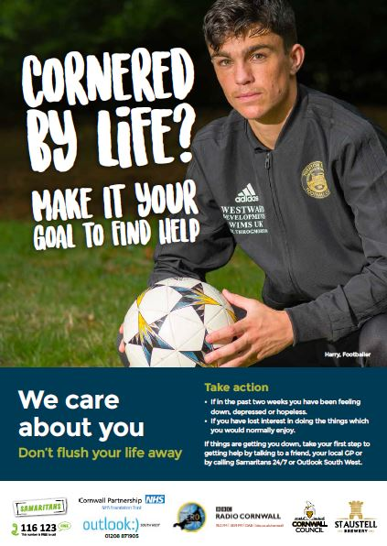
- Don’t Flush Your Life Away – a set of posters to encourage people to talk about their mental health, rather than keep it bottled up!
Don't flush your life away - Cornwall Council
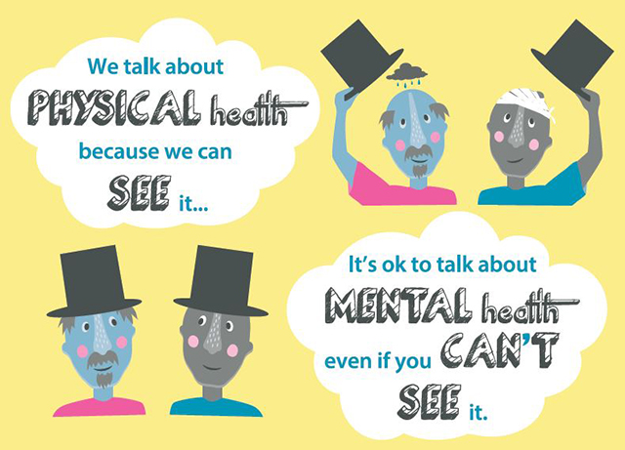

RESPONSE TO A SUSPECTED SUICIDE OF A WORK COLLEAGUE

Immediate response - Acute Phase

- Ensure one person from your senior management team is responsible for coordinating all relevant actions; this provides one point of contact and avoids staff hearing things through different managers.
- Contain the crisis (this is relevant if an employee dies by suicide at the workplace). You need to limit the number of people in the workplace who can see the suicide site and offer immediate comfort and support anyone who has witnessed the suicide or found the body
- Offer support to the family whilst respecting their privacy
- Ensure all staff are informed as soon as possible to pre-empt notification through social media. Being open and honest with your workforce is the best way to stop speculation and conspiracy theories. It is appropriate to use terminology such as ‘possible suicide’ or ‘suspected suicide’ in any staff communication. Please see suggested template for internal staff communication (Appendix 1).
- Identify vulnerable staff and monitor their wellbeing.
- Contact Outlook South West’s Suicide Liaison Service www.cornwallft.nhs.uk/suicide-liaison-service or phone: 01208 871905 (weekdays from 9 a.m. to 1 p.m.) for advice and support if appropriate Direct link to bereavement support leaflet: download.cfm (cornwallft.nhs.uk).
Short Term - Recovery Phase

- Provide comfort and support to staff who need it and promote healthy grieving.
- Identify and link affected employees to appropriate emotional and physiological support. This could be a direct or self-referral to Outlook Southwest for an assessment and appropriate psychological therapy by phone at the number given above, or by email to cft.oswenquiries@nhs.net or suggest they make an appointment to see their GP. Offer support through your own company’s occupational health service (Appendix 1).
Longer term

- Prepare for anniversaries and any other milestone dates to remember the deceased. See page 11 of https://theactionalliance.org/resource/managers-guide-suicide-postvention-workplace-10-action-steps-dealing-aftermath-suicide
- Transition postvention to suicide prevention – in other words, now you are through the immediacy of the suicide make sure your organisation are supporting the mental and physical health needs of employees. To do this, managers need to know how to identify someone who is struggling and then be able to refer them to appropriate services. Further, staff need to know that’s it’s OK to admit to struggling with mental ill health and that acknowledging it is the first step to recovery.
- Provide leadership to develop a Healthy Workplace environment, we have lots of resources on Healthy Workplace - Healthy Cornwall
- Identify key staff to undertake ASIST or Suicide First Aid training to promote a suicide safer workplace. We offer training in many locations, and digitally, across Cornwall so please look at www.healthycornwall.org.uk to see what is available in your area or contact us so we can develop something to support your specific needs. https://www.healthycornwall.org.uk/training/

APPENDICES:

Appendix 1; Community Support Resource List (not exhaustive)

Suicide liaison Service is for anyone who has been affected by suicide. It is open to all without discrimination with regard to age, gender, race, disability, sexual orientation and beliefs. Leaflet available at https://www.cornwallft.nhs.uk/download.cfm?doc=docm93jijm4n12540.pdf&ver=31865
CRUSE Bereavement Care (Cornwall) providing bereavement support for people of all ages. Cornwall@cruse.org.uk
Tel: 0808 8081677 (Young person's helpline)
Tel: 01726 76100 (Cornwall helpline) www.crusecornwall.org.uk

Man Down is a friendly, informal and confidential meet up for men where you can talk, get support or just listen. Meets up across Cornwall. http://www.mandowncornwall.co.uk/

Samaritans. Confidential helpline where you can talk any time you like, in your own way about whatever's getting to you. -face to face at 19 Treyew Road, Truro, TR1 2DY; phone any time day or night; email-response within 24 hours

Tel: 116 123 [free from any phone]
jo@samaritans.org

www.samaritans.org

or go to Samaritan’s self-help app. https://selfhelp.samaritans.org/

National Support Resources

CALM (Campaign Against Living Miserably) a registered charity existing to prevent male suicide in the UK. Available at: https://www.thecalmzone.net/
Helpline 5pm–midnight, 365 days a year; 0800 58 58 58

SOBS: Survivors of bereavement by suicide. offers support, information and groups for people bereaved by suicide. Available at https://uksobs.org/

APPENDIX 2: suggested Internal Email to staff template (adaptable)
Date:
To: Staff
From: [Name of CEO]
Re: Death of [name of employee]
[Our workplace] is saddened to learn of the death of [employee]; the family has requested that the cause of death be withheld/the cause of death has not yet been confirmed.
The tragic and sudden circumstances of [employee’s] death may cause a range of reactions among our colleagues, so with the family’s permission we are sharing the following information and are offering support for those who might need it.
[Employee] worked for [workplace] for the last [number] years. On [day] [s/he] died around [time] [DO NOT MENTION PLACE OR METHOD USED FOR SUICIDE]. [Employee’s] memorial service will be held on [Date/time], and all employees who wish to attend may be excused. The family would like to welcome all of [his/her] friends and colleague who wish to share in the celebration of [his/her] life. Some of you may be having difficulty coping with the sudden loss of one of our workplace family. We have arranged for [Employee Assistance Program (EAP)/OTHER] professionals to facilitate a crisis counselling session on [Date/Time]. During this group meeting, counsellors will be on hand to support us and answer any questions we may have. Others may prefer individual support at this time. If so, please contact our EAP/or OTHER by calling [contact number/EXT] who can provide details of local resources. For those who would like to talk about what has happened, our HR team is available to you.

[Adapted from A Manager’s Guide to Suicide Postvention in the Workplace, p. 13].

